**Realtime Weather**

**Group 2**

⁠Harmanpreet Kaur, ⁠Gurleen Kaur, Shivam Verma, ⁠Justin Tremblett ⁠and Sasha Greene

**Project Description**

Our team made the decision to develop a weather forecasting app. It will inform users of the current and upcoming weather forecasts. Users can also look for weather forecasts in other places. All of us need to know the weather, and this app will assist users do that.

We use [Weather API - OpenWeatherMap](https://openweathermap.org/api) for this project.

**What features User Would like to have in the app?**

1. As a user, I'd like to save the locations I choose for weather information.

2. As a user, I'd like to see the current weather and a weekly forecast for my chosen location

3.As a user, I'd like to sign in and sign out from my app for a more customised experience

4. As a user, I would like the option of sharing weather condition of the locations.

5. As a user, I would like to see images in the app that show if it is sunny, cloudy, and so on.

**Wireframes:**

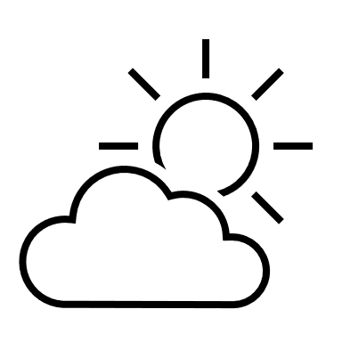

**Register**

**Today’s Weather**

SignUp

****

Password

****

Username

**Realtime Weather**

About Us

Sign Out

**Weather Image**





Change Location

Current Location

Search Location…….

**Setting**

Search

Setting

Weekly Weather

Time

Time

Time

Time

Wednesday











Time

Time

Time

Time







Tuesday

Time

Time

Time

Time

Monday









**Weekly Weather**

**Weather Info**

**Weather Image**





**Time**









**Time**

**Time**

**Time**

Email

****

Username

****

Full Name

****

Password

****

Signup Page

Login Page

Today’s Weather

SignUp

Login